All Saints, All Souls
A Month of Rememberance
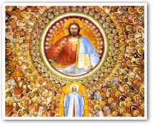
All Saints’ Day – 1st November
We celebrated the feast of All Saints with Mass in Church. The children really responded well to their halloween evening homework of researching a saint so when Fr Jack quizzed them, they knew what to say! Well done parents and carers for supporting. November is the month of remembrance. Our Catholic tradition notes this month as the time to remember all our dead friends and family: the Holy Souls. Our country also says it’s a time to remember all those who have given their lives for our civic values too.
Playground Open!!!!
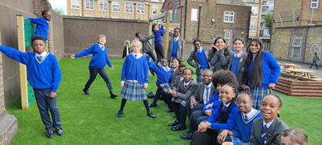
We’re delighted to let you know ‘The Park’ is fully refurbished, resurfaced and in full swing!

How we will remember……
Book of Remembrance
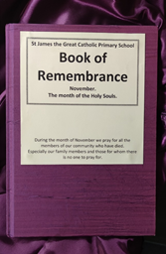
This will be open for writing the names of loved family members and friends on Friday morning from 8:40 until 8:55. Adults and children are welcome to come into the school hall for this. The Book is then presented at the Sunday Mass offertory each week.
Poppies - Remembrance Day
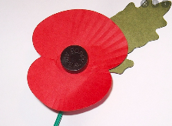
These will be on sale after school each day for the next few weeks and will be especially significant as we approach Remembrance Sunday on the 12th November.
Some amazing things to look forward to this term
Year 5 will be going to the amazing Royal Opera House to see a ballet, the ‘Nutcracker suite’ and Years 4 to 6 will be going to the Unicorn Theatre to see a production of ‘The Bolds’.
OUR SAVING CLUB
Is open weekly on Wednesday morning from 8:30-8:55. Please join and help your child get into good financial habits !
October Research: People of colour who have influenced us
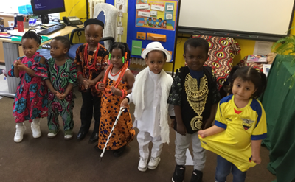
A great response from the childen who brought to our attention a variety of influencial people including Bruno Mars, Richi Sunak, Dorothy Vaughan and Maya Angelou. The following children received the award of a £10 voucher for their excellent work: Gisela, Alexander, Awele, Anabelle, Nhyra & Smiles.
Nursery Children celebrating their heritage by reserching their traditional costume and sharing the splendour.
‘St James the Great Awards’
‘Class Based’ – Please ask your child
Pupils of achievement are as follows:
Aimee & Kevin, Phoebe & Jayden, Millie & Daniel, Zachariah & Gloria, Ebube & Praise and Jamie & Santiago.
‘Pupil Leaders’
‘Play Supporters’ – Aniah and Desereen

Well Done Everyone!

St James the Great, Pray for us.

