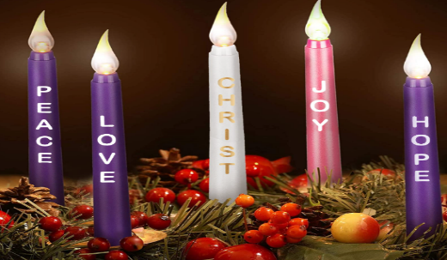

Advent Continues
Please get involved with school and parish over the coming weeks. Go to Mass on Sundays, attend the Nativity Play (KS1) or the Tableau in the Church next Wednesday evening where everyone is welcome. Do something to build our family community as we get ready for Christmas.
Christmas Lights -On!
Thank you for coming out!

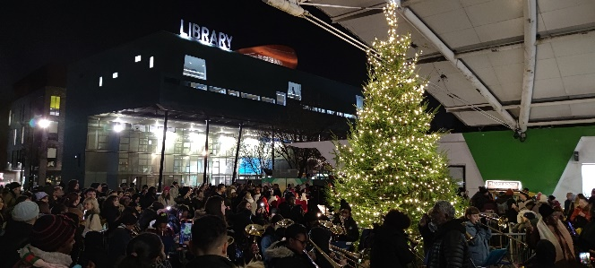
Well done Year 6 and everyone else who braved the freezing temperatures last Friday night. Year 6 warmed the crowd with their excellent brass music and the Mayor was there to have a photo taken with! What fun it was!
Summer Reading Challenge What a Success!!!
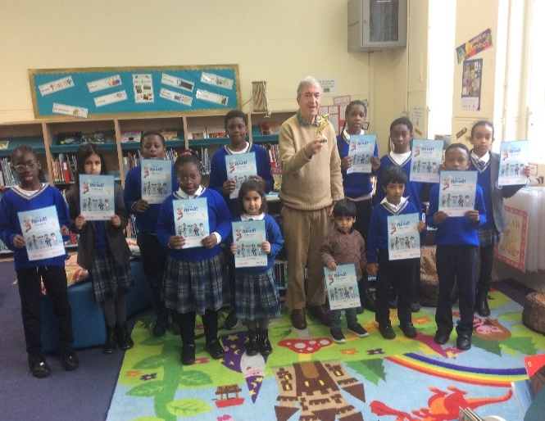

At last Friday’s Achievement assembly the children received their certificates for completing the Summer Reading Challenge and the school won the trophy for having the best effort across the borough this summer. What a great achievement!

Dates for you Diary
Christmas Infant Nativity Play
Reception – Year 2
Tuesday 12th December at 2pm
Christmas Tableau (Years 3,4,5 & 6)
Wednesday 13th December at 7pm. (Church)
Christmas Dinner – Tues 19th Dec
Class Parties – Tues 19th Dec
End of Term- Wed 20th December

Financial Education Centre of Excellence – re-acreditation
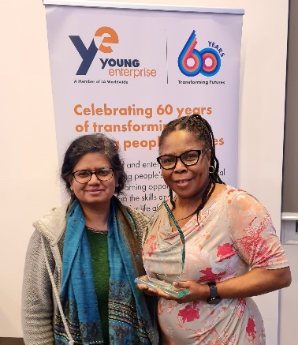
We did it! For the second time, the school has been awarded its status as a Centre of Excellence for Financial Education. Mrs Oduko and Ms Jayawardhana went to claim our special glass trophy.
Family Fund
Please make sure you have paid at the Office. Every penny counts. Thank you!
‘St James the Great Awards’
‘PE’
Pupils of achievement are as follows:
Jeremiah, Philip, Gideon, Tina; Alexander, Amelia; Israel, Johnny; Elijah, Daphne; and Reuel & Brina
‘Inquisitive Learner’
Pupils of achievement are as follows:
Victoria, Nathan, Yoel, Awele, Israel & Mason
‘Pupil Leaders’
‘Finance Champions’
Darasimi & Millie
Well done everyone!
St James the Great, Pray for us.

