Jesus on the mountainside with his diciples

Blessed are the…

This week’s Gospel is the Beatitudes.
Each of the beatitudes tells us something about what it is like to live life the way God wants us to.
Each one starts with the word "Blessed".
Beatitudes describe the blessedness of those who have certain qualities or experiences relating to those belonging to the Kingdom of Heaven.

!!Strike Update!!
Wednesday 1st February

We have been notified by the NEU (National Education Union) that at St James the Great 90% of the Teachers are members. The NEU have requested that all members take strike action. If this were to be the case we would have to close the school for the day. There would also be no Breakfast Club, After School Club or Chior.
You know this is not something we take lightly but with such a high percentage of NEU members it would be unsafe to open the school to pupils. The final decision will be communicated to you via text message by 7:30am on the morning of Wednesday 1st of February. Please make alternative arrangements for you child on this day.

If your child is entitled to a Free School Meal a packed lunch will be available for collection from the School Office between 12 and 1pm.

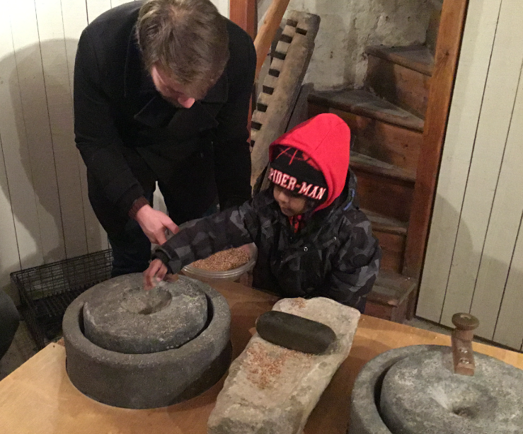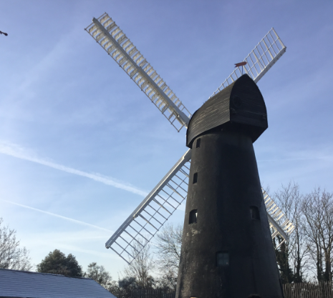
Learning Outside the Classroom-Windmills and Space Craft

At St James the Great we are always looking for high quality learning opportunites that enhance the fantastic learning that takes place in the classroom.
This week has seen our Nursery children go to the Brixton Windmill where they learnt about milling wheat and making bread. This ties in with the book they have been learning about “The Little Red Hen” . On Wednesday our Year 5 Children went to the Science Museum to enhance their “Space” topic. They saw a full-sized replica of Eagle—the lander that took astronauts Moon in 1969 and had an insight into the history of rockets, two real rockets were suspended from the ceiling!
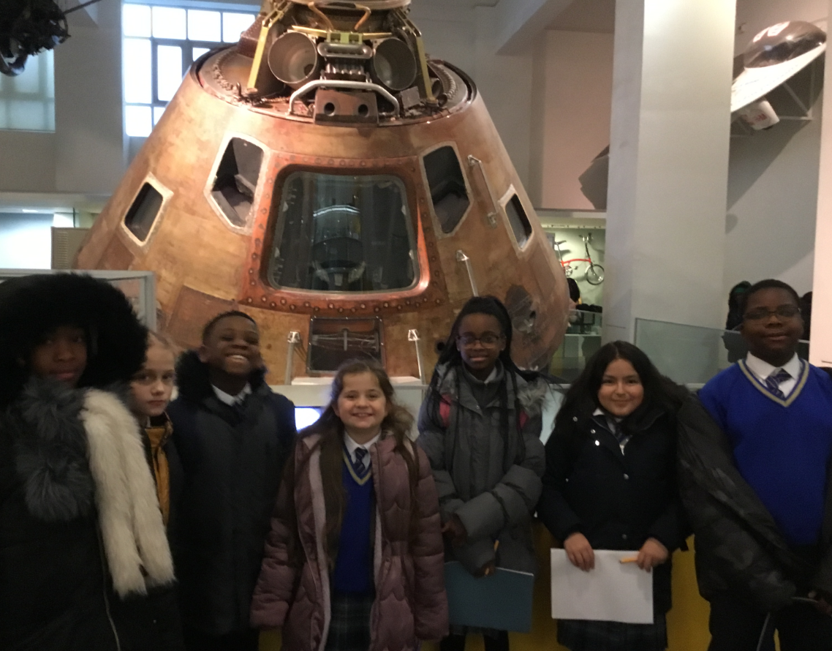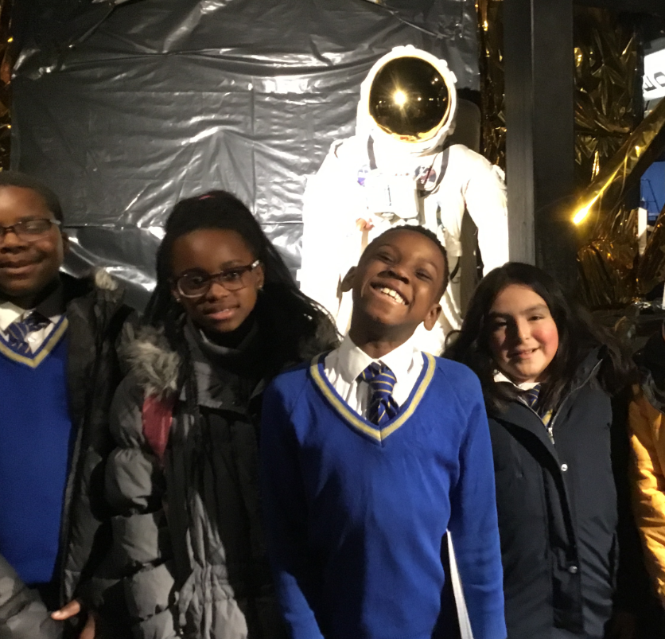

‘St James the Great Awards’
‘Writing – Especially in Other Subjects’
Pupils of achievement are as follows:
Leah Mae & Janet, Patrina & Chidera, Ozioma & Nhyira, Elmer & Sultan, Hope & Anthony and Eliana & Praise.

‘Imaginative Learners’
Pupils of achievement are as follows:
Jane, Anaya, Feranmi, Tina, Adeola & Gabriel

‘Catholic Life Committee’
Joel and Sara.
Well done everyone!
St James the Great, Pray for us.

